Transition curves in Road Design

The purpose of this document is to provide details of various spirals, their characteristics and in what kind of situations they are typically used. Typical spirals (or transition curves) used in horizontal alignments are clothoids (also called as ideal transitions), cubic spirals, cubic parabola, sinusoidal and cosinusoidal.
Index
1 Transition curves in Road Design 1
1.1.1 Transition curves 3
1.1.2 Superelevation 3
1.1.2.1 Method of maximum friction 3
1.1.2.2 Method of maximum superelevation 4
1.1.3 Length of Transition Curve 4
1.2 Clothoid 4
1.2.1 Clothoid geometry 8
1.2.2 Expressions for various spiral parameters 9
1.2.3 Clothoids in different situations 11
1.2.4 Staking out Northing and Easting values for Clothoid 12
1.3 Cubic Spirals 13
1.3.1 Relationships between various parameters 13
1.4 Cubic Parabola 14
1.4.1 Minimum Radius of Cubic Parabola 15
1.5 Sinusoidal Curves 15
1.5.1 Key Parameters 16
1.5.2 Total X Derivation 16
1.5.3 Total Y Derivation 17
1.5.4 Other Important Parameters 17
1.6 Cosinusoidal Curves 18
1.6.1 Key Parameters 19
1.6.2 Total X Derivation 19
1.6.3 Total Y Derivation 20
1.6.4 Other Important Parameters 21
1.7 Sine Half-Wavelength Diminishing Tangent Curve 22
1.7.1 Key Parameters 22
1.7.2 Curvature and Radius of Curvature 23
1.7.3 Expression for Deflection 25
1.7.4 Total X derivation 26
1.7.5 Total Y Derivation 26
1.7.6 Other Important Parameters 26
1.8 BLOSS Curve 27
1.8.1 Key Parameters 27
1.8.2 Total X Derivation 28
1.8.3 Total Y Derivation 28
1.8.4 Other Important Parameters 29
1.9 Lemniscates Curve 30
1.10 Quadratic spirals 30
1.11 Transition curves to avoid 30

Transition curves
Primary functions of a transition curves (or easement curves) are:

- To accomplish gradual transition from the straight to circular curve, so that curvature changes from zero to a finite value.
- To provide a medium for gradual introduction or change of required superelevation.
- To changing curvature in compound and reverse curve cases, so that gradual change of curvature introduced from curve to curve.

To call a spiral between a straight and curve as valid transition curve, it has to satisfy the following conditions.

- One end of the spiral should be tangential to the straight.
- The other end should be tangential to the curve.
- Spiral’s curvature at the intersection point with the circular arc should be equal to arc curvature.
- Also at the tangent its curvature should be zero.
- The rate of change of curvature along the transition should be same as that of the increase of cant.
- Its length should be such that full cant is attained at the beginning of circular arc.

Superelevation
There are two methods of determining the need for superelevation.

Method of maximum friction
In this method, we find the value of radius above which we don’t need superelevation needs to be provided. That is given by the following equation.

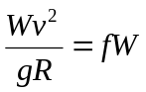

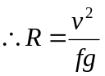

If the radius provided is less than the above value… that has to be compensated by

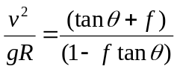

Method of maximum superelevation

In this method – we just assume that there is no friction factor contributing and hence make sure that swaying due to the curvature is contained by the cant.

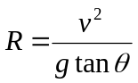

Length of Transition Curve
Typically minimum length of transition curve is equal to the length of along which superelevation is distributed. If the rate at which superelevation introduced (rate of change of superelevation) is 1 in n, then

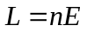

E - in centimeters
n - 1 cm per n meters

By time rate (tr):

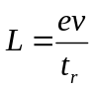
tr – time rate in cm/sec

By rate of change of radial acceleration:

An acceptable value of rate of change of centrifugal acceleration is 1 ft/sec**2/sec or (0.3m/sec**2/sec), until which user doesn’t find any discomfort. Based on this:
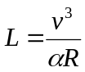

 – rate of change of radial acceleration in m/sec**3

Clothoid
An ideal transition curve is that which introduces centrifugal force at a gradual rate (by time t).

So,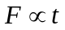

Centrifugal force at any radius r is given by:

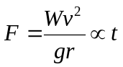

Assuming that the speed of the vehicle that is negotiating the curve is constant, the length of the transition negotiated too is directly proportional to the time.

l  t

So, l  1/r

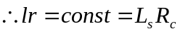

Thus, the fundamental requirement of a transition curve is that its radius is of curvature at any given point shall vary inversely as the distance from the beginning of the spiral. Such a curve is called clothoid of Glover’s spiral and is known as an ideal transition.

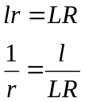

As 1/r is nothing but the curvature at that point, curvature equation can be written as:

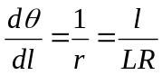

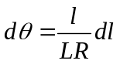

Integrating, we get
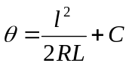

Where  is the deflection angle from the tangent (at a point on spiral length l)

At l = 0;  = 0

Substituting these, we get C = 0

Hence the intrinsic equation of the ideal transition curve is:
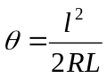 (In Cartesian coordinates, slope can be expressed as)

Also the total deflection angle subtended by transition curve of length L and radius R at the other end is given by:

s = L/2R (a circular arc of same length would change the direction by L/R)

Further, if we examine the curvature equation it is evident that rate of change of curvature is constant.
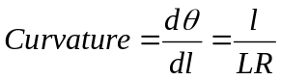 (A function of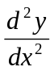)

Differentiating both sides with respect to l, we get

Rate of change of curvature = 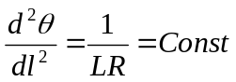(also expressed as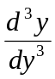)

Following illustration gives example of a S-C-S curve fit between two straights.

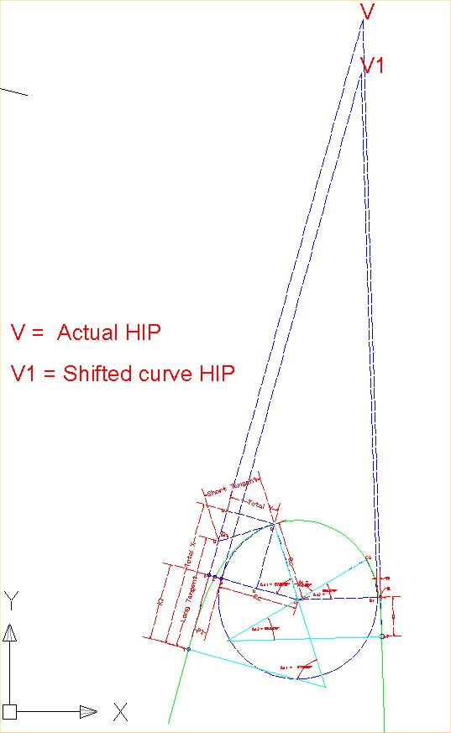

Clothoid geometry

Details of an S-C-S fitting are presented in the following figure. Spiral before curve (points TCD) is of length 175 meters and spiral after the curve is of 125 meters.

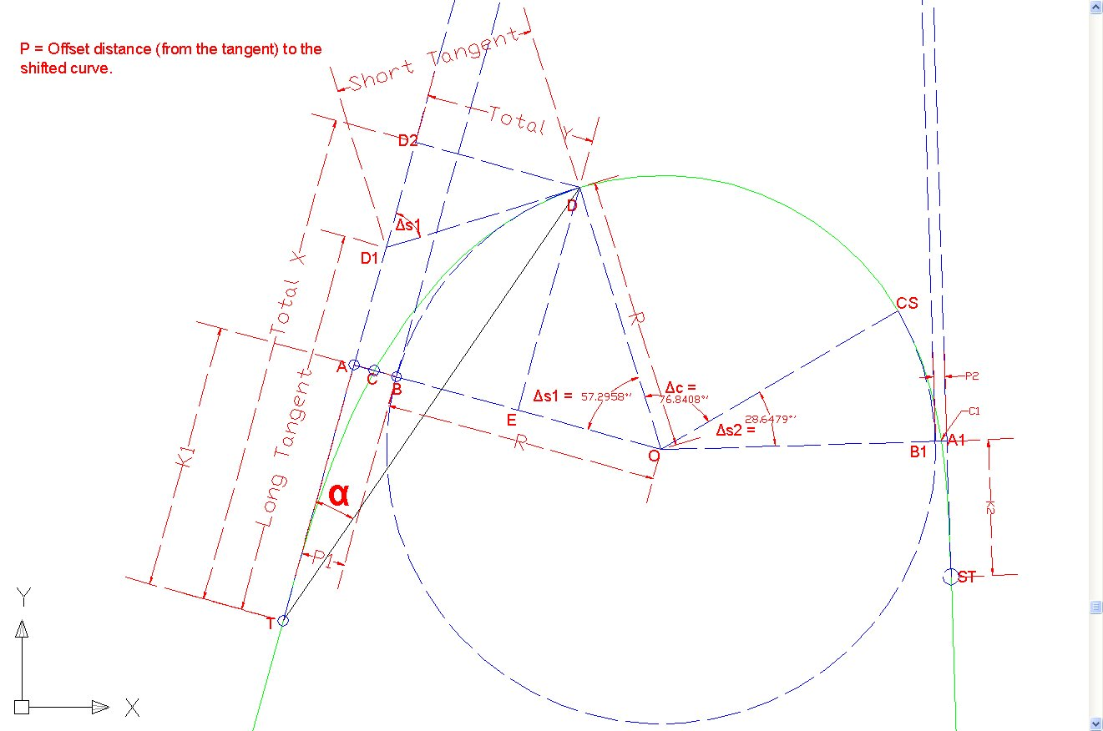

Following are the key parameters that explain this geometry.

LDT terms | In the figure | Description
L1 | TCD | Length of the spiral – from TS to SC
PI | V | Point of horizontal intersection point (HIP)
TS | T | Point where spiral starts
SC | D | Point where spiral ends and circular curve begins
i1 | s1 | Spiral angle (or) Deflection angle between tangent TV tangential direction at the end of spiral.
T1 | TV | Total (extended) tangent length from TS to PI
X1 | Total X = TD2 | Tangent distance at SC from TS
Y1 | Total Y = D2D | Offset distance at SC from (tangent at) TS
P1 | AB | The offset of initial tangent in to the PC of shifted curve (shift of the circular curve)
K1 | TA | Abscissa of the shifted curve PC referred to TS (or tangent distance at shifted PC from TS)
 | B | Sifted curve’s PC
LT1 | TD1 | Long tangent of spiral in
ST1 | DD1 | Short tangent of spiral in
RP | O | Center point of circular curve
c | c | Angle subtended by circular curve in radians
 |  | Total deflection angle between the two tangents
R | R | Radius of the circular curve

Similarly are the parameters for the second curve. Also note the following points that further helps in understanding the figure shown above.

- Line passing through TV is the first tangent
- V is the actual HIP
- Actual circular curve in the alignments is between D and CS
- The dotted arc (in blue colour) is extension of the circular arc
- The dotted straight BV1 (in blue colour parallel to the original tangent) is tangential line to the shifted arc.
- B is the shifted curve’s PC point.
- So OB is equal to R of circular curve and OA is collinear to OB and perpendicular to the actual tangent.
- D is the SC point
- DD1 is the tangent at SC
- DD2 is a perpendicular line to the actual (extended) tangent.
- And similarly for the spiral out.

Expressions for various spiral parameters

Two most commonly used parameters by engineers in designing and setting out a spiral are L (spiral length) and R (radius of circular curve). Following are spiral parameters expressed in terms of these two.

  - Flatness of spiral = 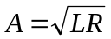
  - Spiral deflection angle(from initial tangent) at a length l (along spira)l = 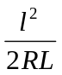
  - 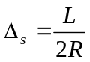 = Spiral angle (subtended by full length)
  -  = s1+ c+ s2 (where c is the angle subtended by the circular arc).

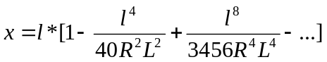

At l = L (full length of transition)

  - 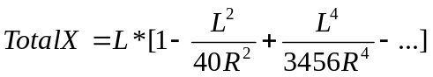

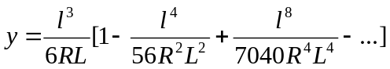

At l = L (full length of transition)

  - 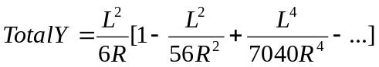
  - 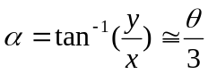 = Polar deflection angle
P = shift of the curve = AE – BE

  - 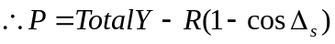
  - K = Total X – R*SINs (= TA. This is also called as spiral extension)

Total (extended) tangent = TV = TA + AV

  - Tangent (extended) length = TV = 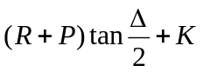
In the above equation we used total deflection angle 
P* TAN/2 is also called as shift increment;

  - Long Tangent = TD1 = (Total X) – (Total Y)*COTs
  - Short Tangent = DD1 = (Total Y) *(COSECs)

Some cool stuff:- At shifted curve PC point length of spiral gets bisected. This curve length TC = curve length CD.

Clothoids in different situations

Simple Clothoid
Simple clothoid is the one which is fit between a straight section and a circular curve for smooth transition. Key parameters are explained in section 2.2.2

Reversing Clothoid
This consists of two Clothoids with opposing curvatures and is generally fit between two curves of opposite direction. In the geometry an SS (spiral-spiral) point is noticed with ZERO curvature. Also typically this should be the point at which flat surface (cross section) happens.

Besides the parameters explained in section 2.2.2 (for each of the spirals) following conditions are usually observed.

- For unequal A1 and A2 (for R1 > R2) - 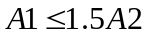
- For the symmetrical reversing clothoid –
The common Clothoid parameter can be approximated by:
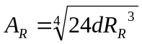

Where d is the distance between two circular curves
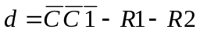

and surrogate radius 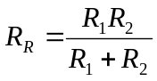

Egg-shaped Clothoid
This is fit between two curves of same direction, but with two different radii. Conditions for successful egg-shaped curve are:
- Smaller circular curve must be on the inside of the larger circular curve.
- They are not allowed to intersect with each other and should not be concentric.

The egg-shaped spiral parameter can be approximated to:

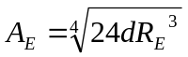

Where d is the distance between two circular curves
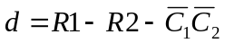

and surrogate radius 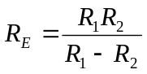

Staking out Northing and Easting values for Clothoid
We know station, northing (N) and easting (E) values of the TS point. Also from the equations given in the Sections 2.2.1 and 2.2.2, we could get various points on the spiral. Using these we could extract (N, E) values of any arbitrary point on the spiral. Suppose

- l is the length of the spiral (from TS) at any arbitrary point on spiral
- L is the total length of the spiral
- R is the radius of circular curve (at the end of the spiral).
- 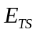 is easting (or x value) of the spiral start point TS in Cartesian coordinate system.
- 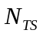 is northing (or y value) of the spiral start point TS in Cartesian coordinate system.
- 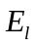 is easting (or x value) of arbitrary point on the spiral (at length l).
- is northing (or y value) of arbitrary point on the spiral (at length l).
- 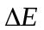 is change in the easting from TS to arbitrary point on spiral.
- 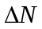 is change in the northing from TS to arbitrary point on spiral. 
-  is the angle between East (X) axis and the tangent measured counter-clockwise
-  is the angle subtended at TS by extended tangent and the chord connecting TS and arbitrary point on spiral (is positive if the spiral is right hand side; and negative if the spiral is left hand side).
- d is the length of the spiral chord from TS to point any point on the spiral.
- 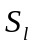 is the station value of the alignment at that arbitrary point.
- 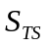is the station value of the alignment at TS

From above information, we know that
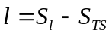
Knowing the value of l
(Pre-approximation equations see section 2.2.2)

(Pre-approximation equations see section 2.2.2)

Once x and y are known

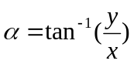
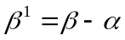 = Angle subtended by chord (from TS to the point on spiral) with respect to X axis (measured counter-clockwise)

Also length of the chord = 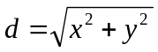

With these we can compute
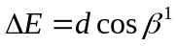
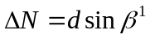

Given this 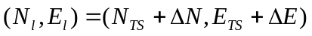

If we need (N,E) values at regular intervals (say 50 m) along the spiral we can compute them using the above set of equations.

Cubic Spirals
This is first order approximation to the clothoid.

If we assume that sin = , then dy/dl = sin =  = l**2/2RL
On integrating and applying boundary conditions we get,

  - 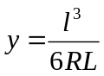
  - 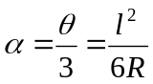

Relationships between various parameters

Most of the parameters (Like A, P, K Etc…) for cubic spiral are similar to clothoid. Those which are different from clothoid are:

There is no difference in x and Total X values, as we haven’t assumed anything about cos.

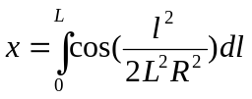

At l = L (full length of transition)

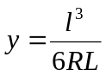

At l = L (full length of transition)

  - 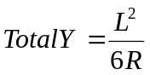
  - = Polar deflection angle

Up to 15 degrees of deflection - Length along Curve or along chord (10 equal chords)? 

Cubic Parabola
If we assume that cos = 1, then x = l.
Further if we assume that sin = , then

  - x = l and 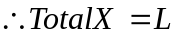
  - 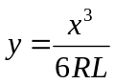and 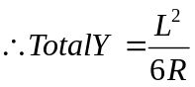

Cosine series is less rapidly converging than sine series. This leads to the conclusion that Cubic parabola is inferior to cubic spiral.
However, cubic parabolas are more popular due to the fact that they are easy to set out in the field as it is expressed in Cartesian coordinates.

Rest all other parameters are same as clothoid. Despite these are less accurate than cubic spirals, these curves are preferred by highway and railway engineers, because they are very easy to set.

Minimum Radius of Cubic Parabola

Radius at any point on cubic parabola is 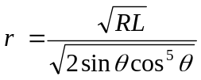
A cubic parabola attains minimum r at 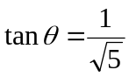
So, 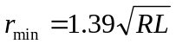

So cubic parabola radius decreases from infinity to at 24 degrees, 5 min, 41 sec and from there onwards it starts increasing again. This makes cubic parabola useless for deflections greater than 24 degrees.

Sinusoidal Curves
These curves represent a consistent course of curvature and are applicable to transition between 0 to 90 degrees of tangent deflections. However these are not popular as they are difficult to tabulate and stake out. The curve is steeper than the true spiral.

Following is the equation for the sinusoidal curve

  - 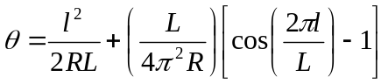

Differentiating with l we get equation for 1/r, where r is the radius of curvature at any given point.

  - 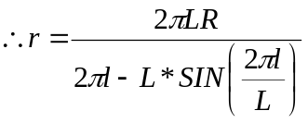

X and Y values are calculated dl*cos, and dl*sin.

Key Parameters
Radius equation is derived from the fact that
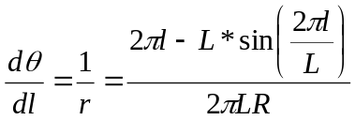

If we further differentiate this curvature again w.r.t length of curve we get

  - Rate of change of curvature = 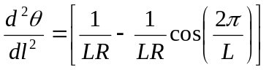

Unlike clothoid spirals, this “rate of change of curvature” is not constant in Sinusoidal curves. Thus these “transition curves” are NOT true spirals – Chakri 01/20/04

Two most commonly used parameters by engineers in designing and setting out a “transition curve are L (spiral length) and R (radius of circular curve). Following are spiral parameters expressed in terms of these two.

  - Spiral angle at a length l along the spiral =
  - = Spiral angle [subtended by full length (or) l = L]
 = s1+ c+ s2 (where c is the angle subtended by the circular arc).

Total X Derivation

 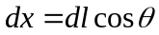

  - 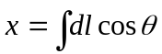, where

To simplify the problem let us make following sub-functions:

  - If 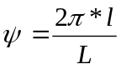

At l = L (full length of transition); x=X and  = . Substituting these in above equation we get:

Total Y Derivation
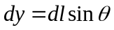

  - 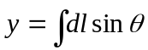, where

Other Important Parameters

At l = L (full length of transition);  becomes spiral angle = s. Substituting l=L in equation 20 we get:

  - 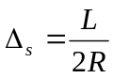(deflection between tangent before and tangent after, of the transition curve)
  - 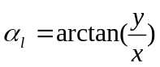 = Polar deflection angle (at a distance l along the transition)
  - 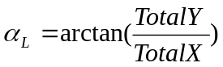 = Angle subtended by the spiral’s chord to the tangent before
P = shift of the curve = AE – BE
  - 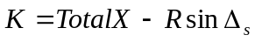 (= TA. This is also called as spiral/transition extension)

Total (extended) tangent = TV = TA + AV

  - Tangent (extended) length = TV =
In the above equation we used total deflection angle 
P* TAN/2 is also called as shift increment;

  - Long Tangent = TD1 = 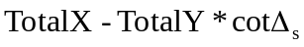
  - Short Tangent = DD1 = 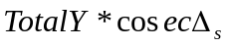

Some cool stuff: - What is the length of spiral by shifted curve PC point. Is curve length TC = curve length CD.

Cosinusoidal Curves

Following is the equation for the Cosinusoidal curve

  - 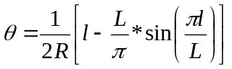

Differentiating with l we get equation for 1/r, where r is the radius of curvature at any given point.
  - 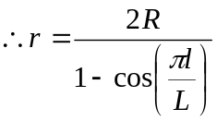

Key Parameters

Previous equation is derived from the fact that
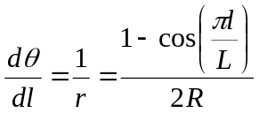

If we further differentiate this curvature again w.r.t length of curve we get

  - Rate of change of curvature = 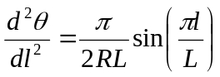

Unlike clothoid spirals, this “rate of change of curvature” is not constant in Cosinusoidal curves. Thus these “transition curves” are NOT true spirals

Two most commonly used parameters by engineers in designing and setting out a “transition curve are L (spiral length) and R (radius of circular curve). Following are spiral parameters expressed in terms of these two.

  - Spiral angle at a length l along the spiral =
  - = Spiral angle [subtended by full length (or) l = L]
  -  = s1+ c+ s2 (where c is the angle subtended by the circular arc).

Total X Derivation

 

  - 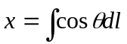

To simplify the problem let us make following sub-functions:

From eqn. 43 we get -> 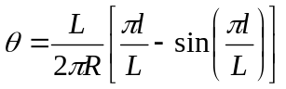

  - If 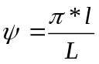
  - 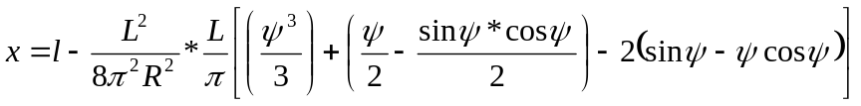

At l = L (full length of transition); x=X and  = . Substituting these in above equation we get:

Total Y Derivation

From eqn. 43 we have 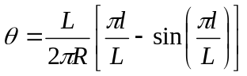

  - If

At l = L (full length of transition); x=X and  = . Substituting these in above equation we get:

Other Important Parameters

At l = L (full length of transition);  becomes spiral angle = s. Substituting l=L in equation 20 we get:

  - (deflection between tangent before and tangent after, of the transition curve)
  - = Polar deflection angle (at a distance l along the transition)
  - = Angle subtended by the spiral’s chord to the tangent before
P = shift of the curve = AE – BE
  - (= TA. This is also called as spiral/transition extension)

Total (extended) tangent = TV = TA + AV

  - Tangent (extended) length = TV =
In the above equation we used total deflection angle 
P* TAN/2 is also called as shift increment;

  - Long Tangent = TD1 =
  - Short Tangent = DD1 =

Some cool stuff: - What is the length of spiral by shifted curve PC point. Is curve length TC = curve length CD.

Sine Half-Wavelength Diminishing Tangent Curve
This form of equation is as explained by the Japanese requirement document. On investigating the equations given by Japanese partners, it is found that this curve is an approximation of “Cosinusoidal curve” and is valid for low deflection angles.

Equation given in the above said document is 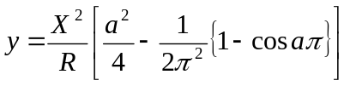where 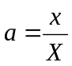 and x is distance from start to any point on the curve and is measured along the (extended) initial tangent; X is the total X at the end of transition curve.

Key Parameters

Substituting a value in the above equation we get

  - 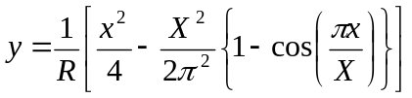

Suppose if we assume a parameter  (in radians) as a function of x

  - as in 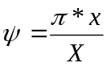
  - 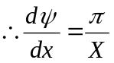 and 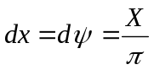

then equation 69 can be re-arranged as:

  - 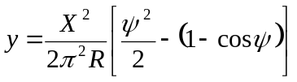

Derivation of y with respect to x is

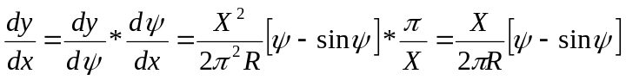

  - 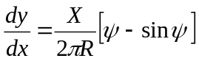

But we know that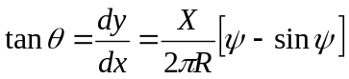, where  is deflection angle of the curve w.r.t initial tangent.

At full length of transition x = X and hence  = . And  = s (total deflection angle of curve)

  - 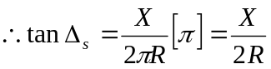

Rewriting 73 using above equation we get
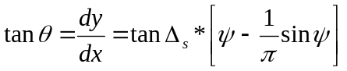

Hence the name “sine half-wavelength diminishing tangent”.

Curvature and Radius of Curvature

Curvature at any point on a curve is inversely proportional to radius at that point. Curvature is typically expressed as 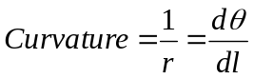

In Cartesian coordinates we can express the same as
  - 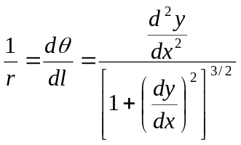

Differentiating equation 73 with respect to x again, we get

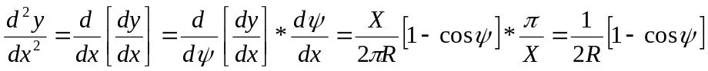

  - 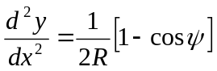

substituting equations 76 and 73 in to 75 we get
  - 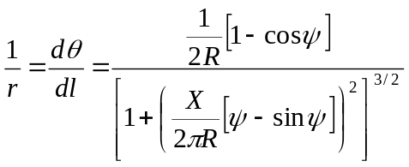

Suppose Rs is the radius of curve at x = X (where it meets simple circular curve);
at x = X, becomes . Substituting these in equation 77 we get

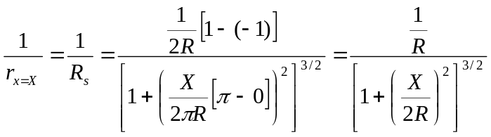

  - 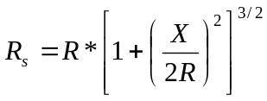

So far we haven’t made any approximations and this equation of Rs is very accurate for the curve given – Chakri 01/25/04

However purpose of a transition is to gradually introduce (or change) curvature along horizontal alignment, and curvature of this transition curve at the point where it meets the circular curve should be equal to that of circular curve. It is obvious from the above equation (no. 78) that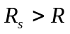, unless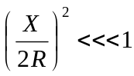, in other wards X<<2R.

Thus this curve function will be a good transition, only if spiral is small (compared to radius) or for large radii for circular curves or when the deflection is for the spiral is too small.

This warrants to the assumption that
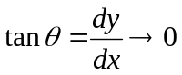 and 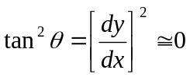

substituting above expression in to equation 75 we get
  - 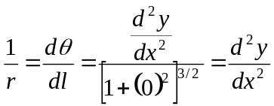

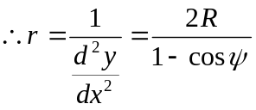

Expression for Deflection

From equation 79 we know that
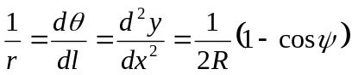

When and , it is safe to assume that
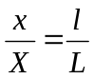

This assumption is more accurate than cos () =1, where X = L. In the current assumption, X stays less that the spiral length.

  - 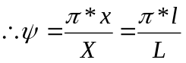 and
  - 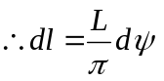

using them with equation 79
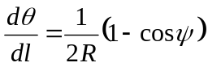

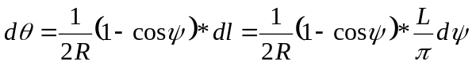

Integrating both sides we get
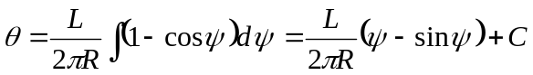

when l=0,  =0,  = 0 and substituting them in above equation we get C = 0.

  - 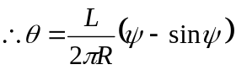

or 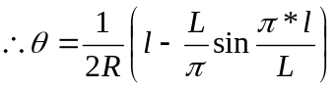 or 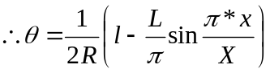

Total X derivation

By carefully examining the equation 83, it is evident that sine half-wavelength diminishing tangent curve deflection expression is very same as Cosinusoidal curve.

Hence we can conclude that the “Total X” of this curve is similar to one in equation 55.

Total Y Derivation
To start with this curve is expressed
At the full length of the spiral -> l = L; x = X and y = Y

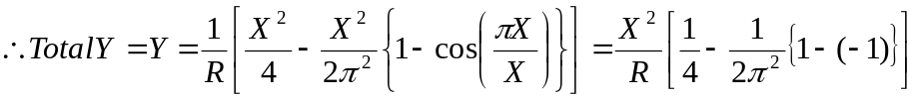

Other Important Parameters

At l = L (full length of transition);  becomes spiral angle = s. Substituting l=L in equation 20 we get:
  - (deflection between tangent before and tangent after, of the transition curve)

But from equation 73 we know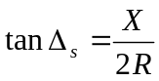. So 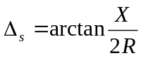

  - = Polar deflection angle (at a distance l along the transition)
  - 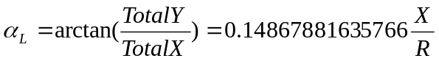 = Angle subtended by the spiral’s chord to the tangent before
P = shift of the curve = AE – BE
  - (= TA. This is also called as spiral/transition extension)

Total (extended) tangent = TV = TA + AV
  - Tangent (extended) length = TV =
In the above equation we used total deflection angle 
P* TAN/2 is also called as shift increment;

  - Long Tangent = TD1 =
  - Short Tangent = DD1 =

BLOSS Curve
Dr Ing., BLOSS has proposed, instead of using the Clothoid the parabola of 5th degrees as a transition to use. This has the advantage vis-à-vis the Clothoid that the shift P is smaller and therefore longer transition, with a larger spiral extension (K). This is an important factor in the reconstruction of track, if the stretch speed is supposed to be increased. Moreover this is more favorable from a load dynamic point of view if superelevation ramp arises.

Key Parameters

Following is the equation for deflection angle as a function of transition curve
  - 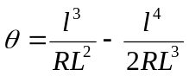

Hence the curvature equation can be written as:

  - 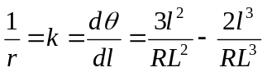

  - 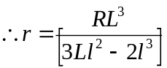 is the equation for radius at any point along the curve where length to that point from start is l.

Total X Derivation
 

  - 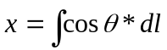, where

using Taylor’s series for 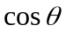 integrating – and substituting l = L we get
  - 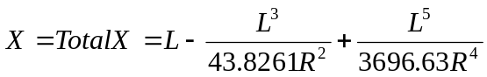

Total Y Derivation
 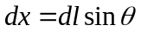

  - 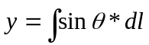, where

using Taylor’s series for 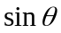 integrating it we get

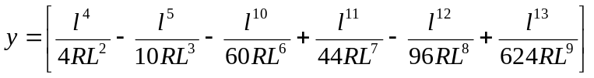

and substituting l = L we get
  - 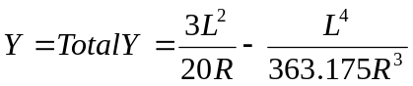

Other Important Parameters
At l = L (full length of transition);  becomes spiral angle = s. Substituting l=L in equation 92 we get:
  - (deflection between tangent before and tangent after, of the transition curve)
  - = Polar deflection angle (at a distance l along the transition)
  - = Angle subtended by the spiral’s chord to the tangent before

P = shift of the curve = AE – BE
  - 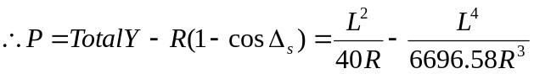
  - (= TA. This is also called as spiral/transition extension)
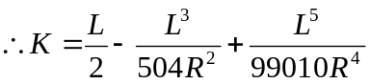

Total (extended) tangent = TV = TA + AV

  - Tangent (extended) length = TV =
In the above equation we used total deflection angle 
P* TAN/2 is also called as shift increment;

  - Long Tangent = TD1 =
  - Short Tangent = DD1 =

Some cool stuff: - What is the length of spiral by shifted curve PC point. Is curve length TC = curve length CD.

Lemniscates Curve
This curve is used in road works where it is required to have the curve transitional throughout having no intermediate circular curve. Since the curve is symmetrical and transitional, superelevation increases till apex reached. It is preferred over spiral for following reasons:
- Its radius of curvature decreases more gradually
- The rate of increase of curvature diminishes towards the transition curve – thus fulfilling the essential condition
- It corresponds to an autogenous curve of an automobile

For lemniscates, deviation angle is exactly three times to the polar deflection angle.

Quadratic spirals

If l > L/2, then

Following is the equation for the quadratic curve
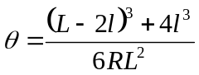

Differentiating with l we get equation for 1/r, where r is the radius of curvature at any given point.
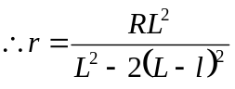

Else
Following is the equation for the quadratic curve
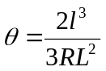

Differentiating with l we get equation for 1/r, where r is the radius of curvature at any given point.
